**Oracle 12c Grid Infrastructure Installation**

**-------------------------------------------------------------------------------------------------------------**

**Platform :** Red Hat Enterprise Linux Server release 6.4 (Santiago)

**Architecture :** x86_64

**Cluster Nodes :** scrbusidkcph021, scrbusidkcph022

mkdir –p /opt/app/oracle/product/11.2.0/grid

chown –R oracle:dba /opt/app/oracle/product/11.2.0/grid

chmod –R 755 /opt/app/oracle/product/11.2.0/grid

mkdir –p /opt/app/oracle/orabase

chown –R oracle:dba /opt/app/oracle/orabase

chmod –R 755 /opt/app/oracle/orabase

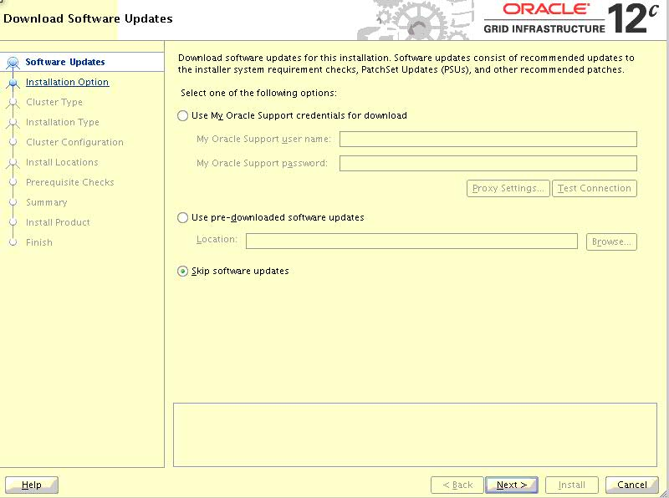

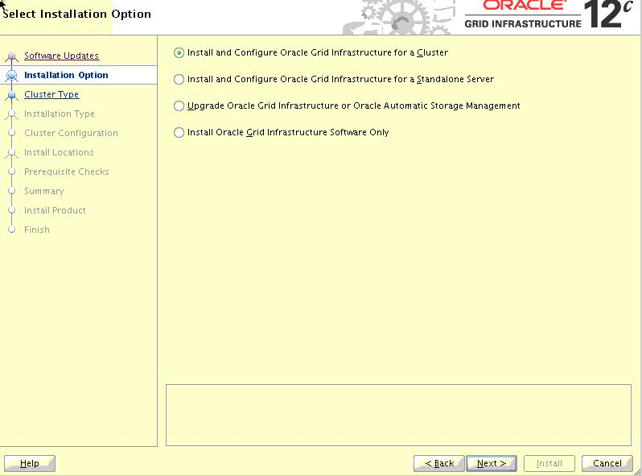

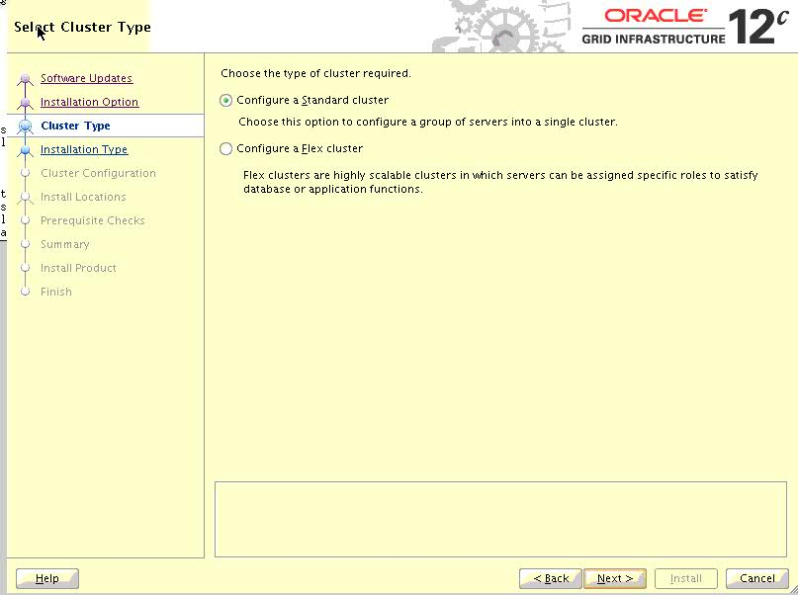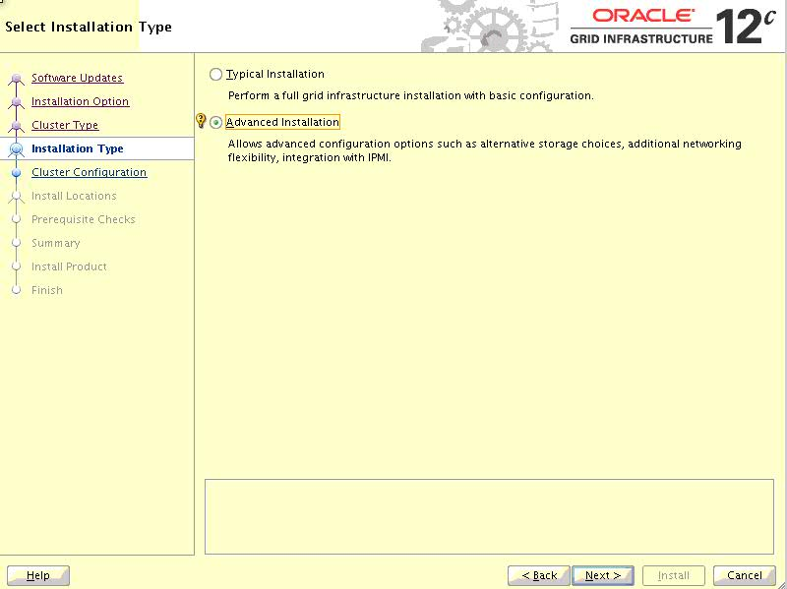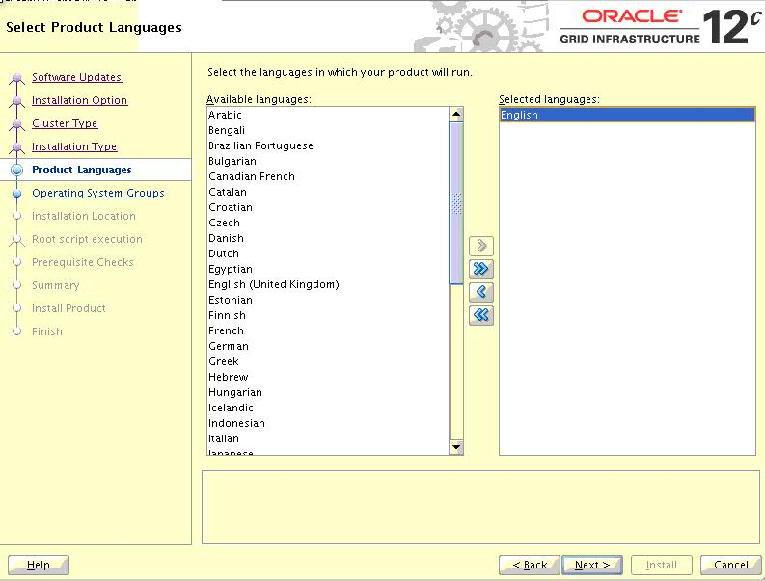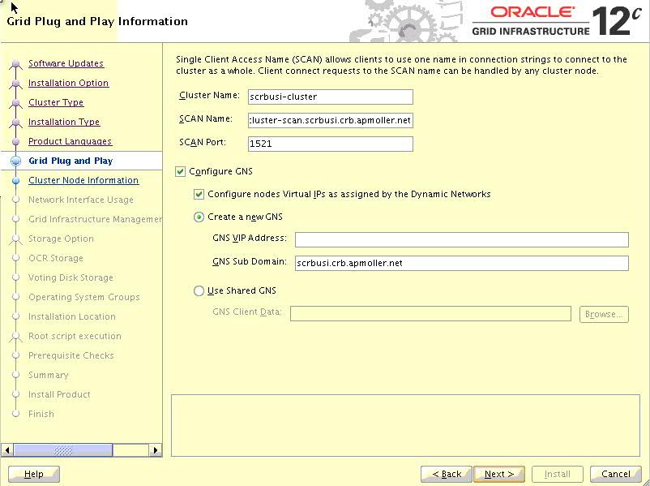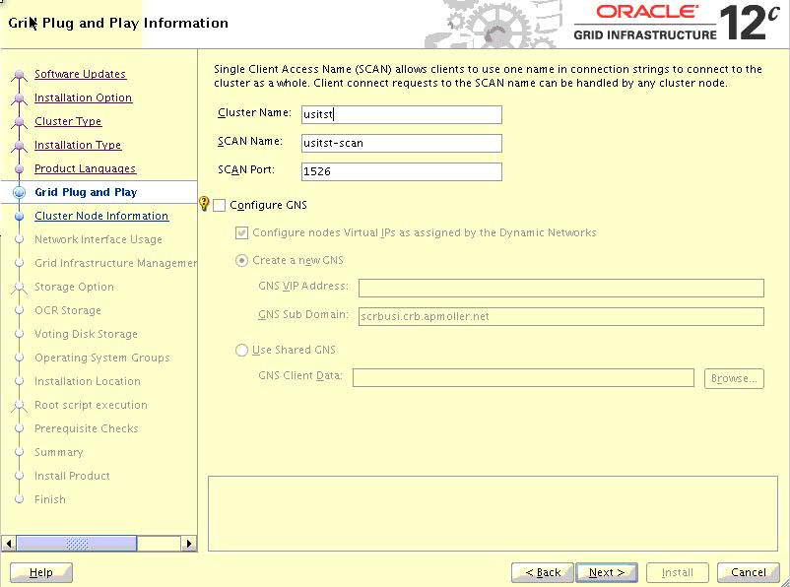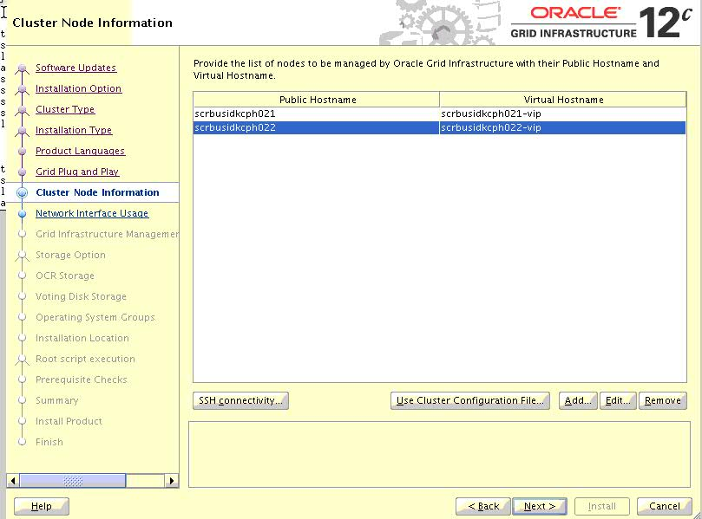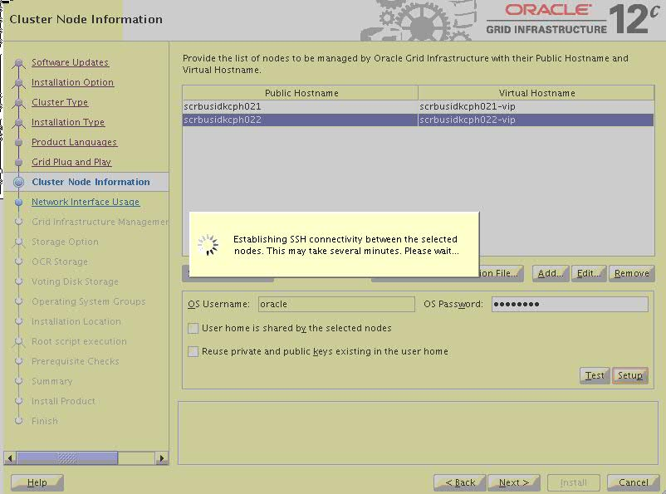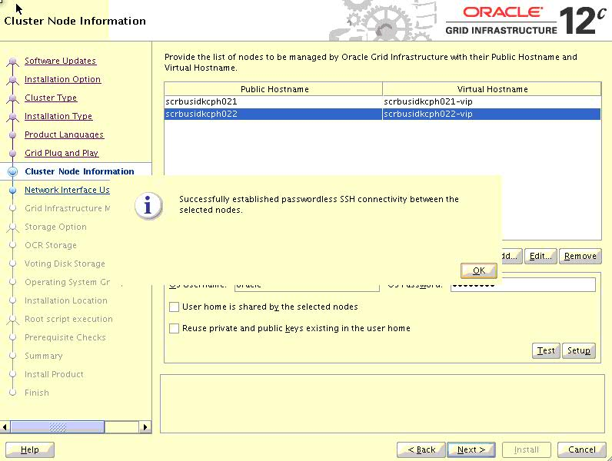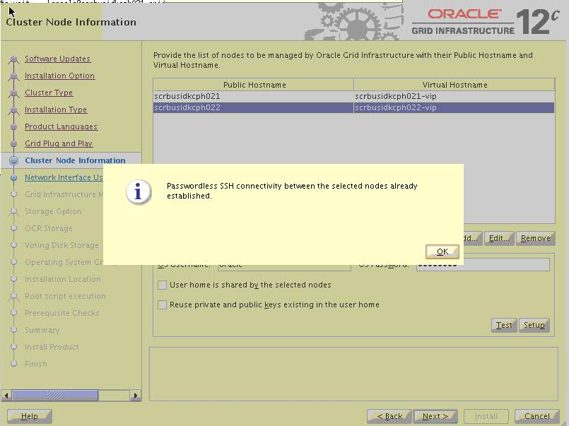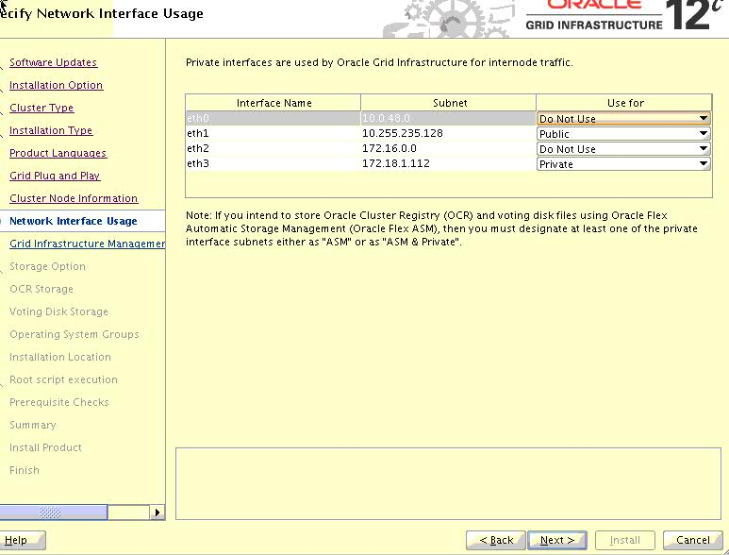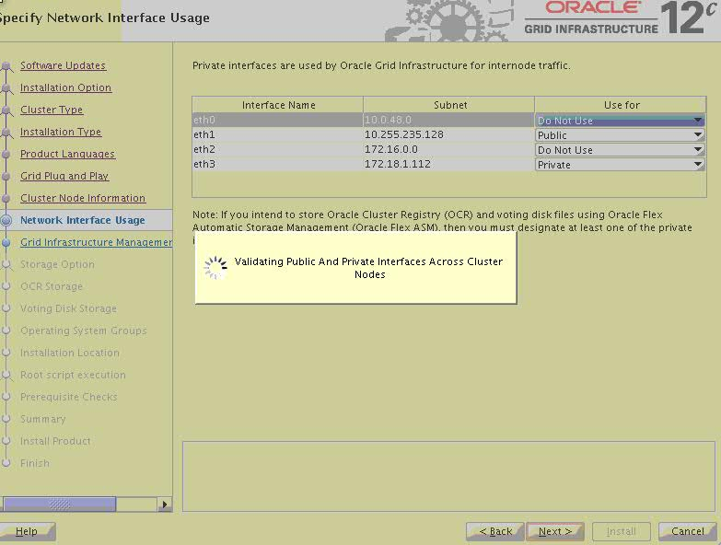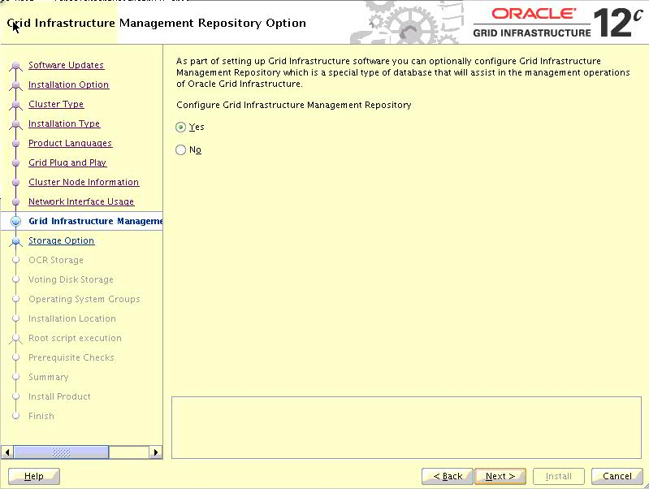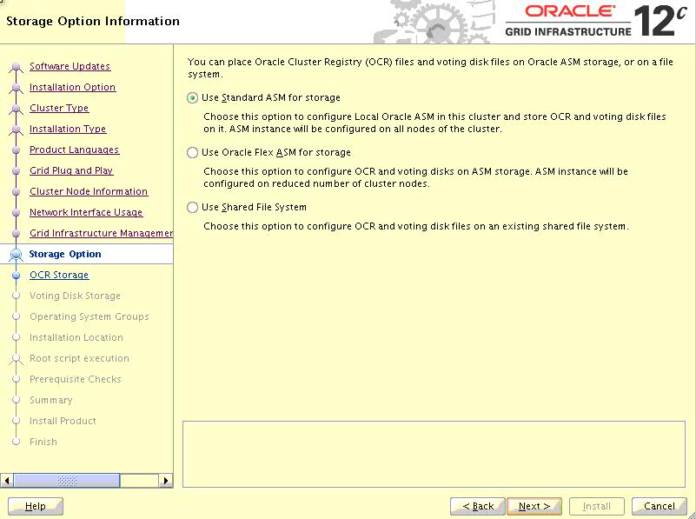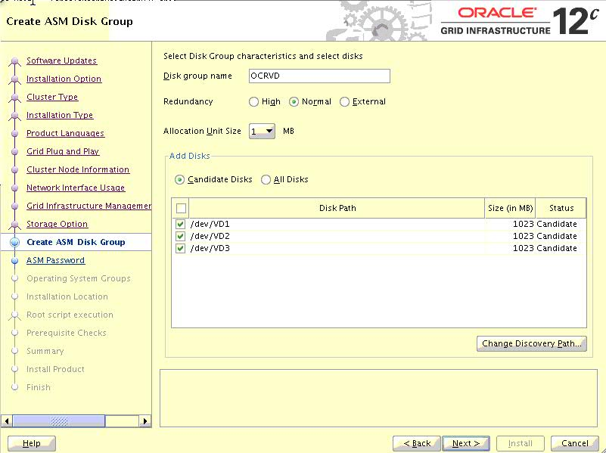

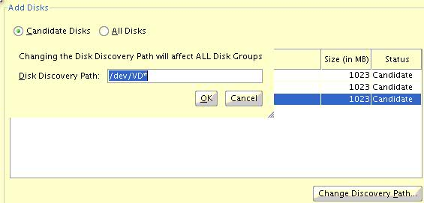

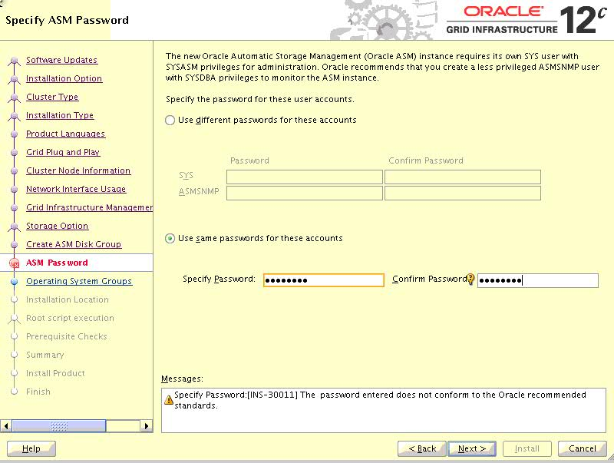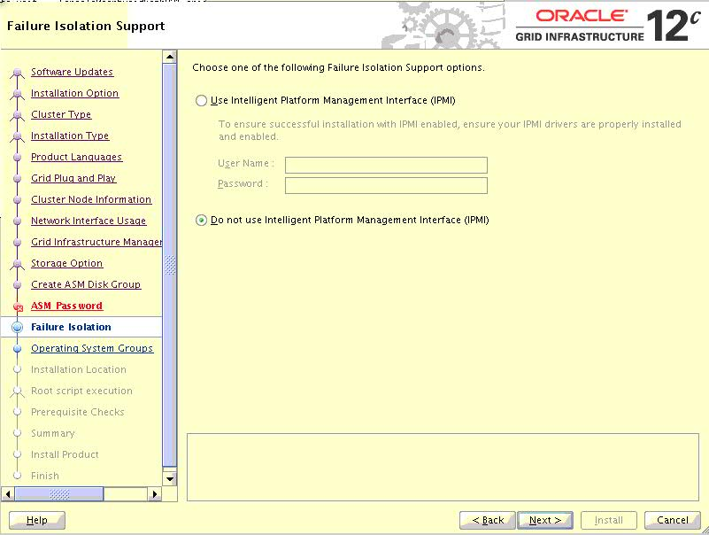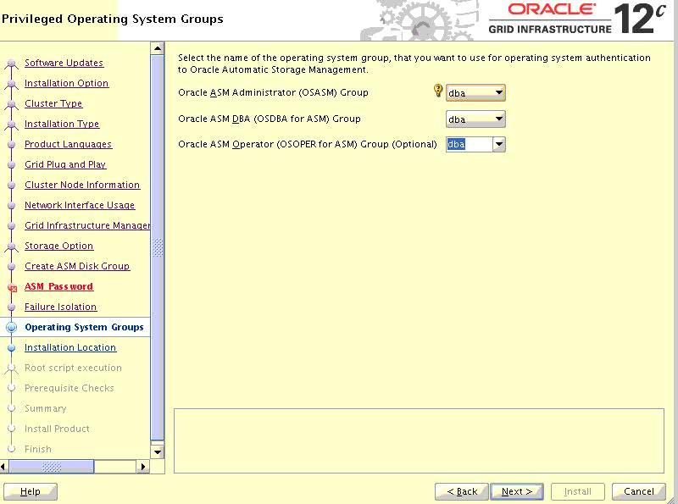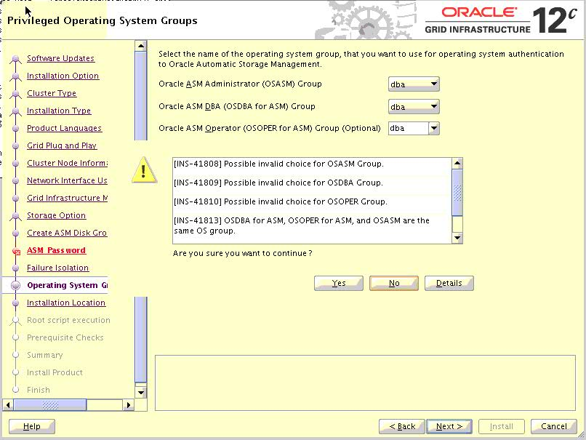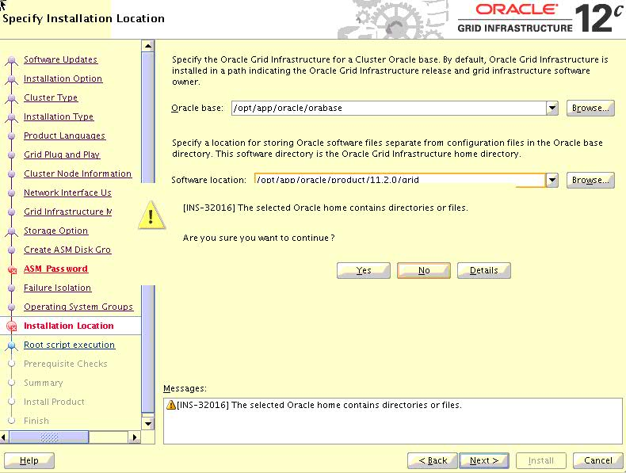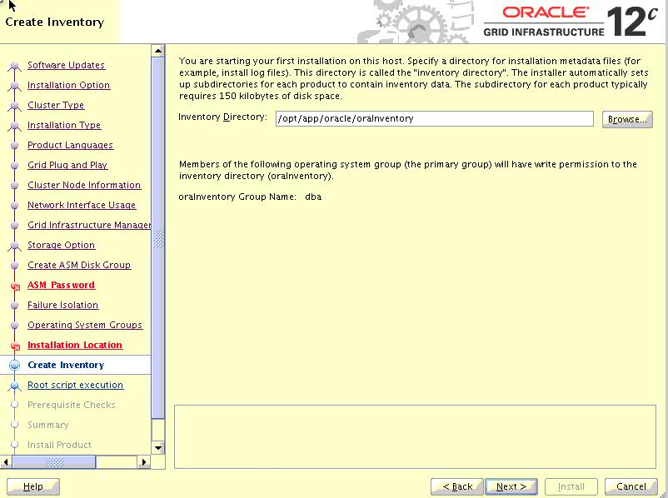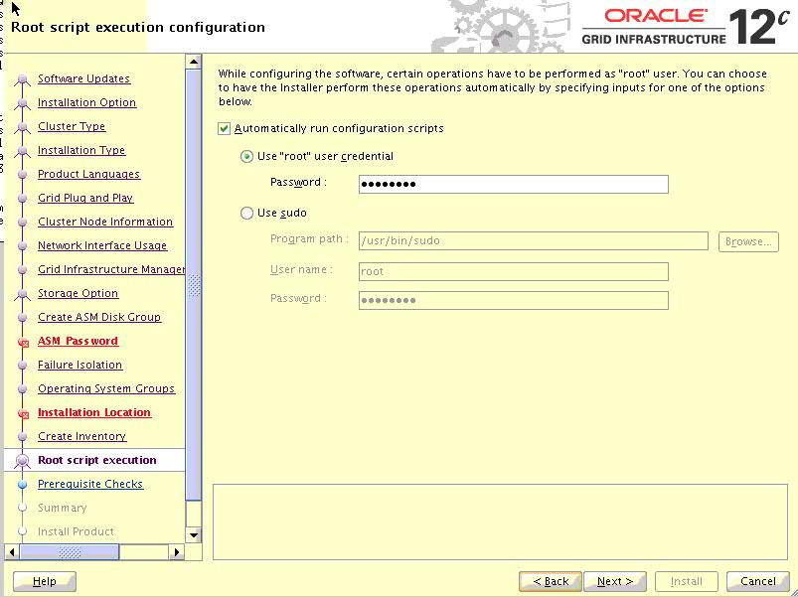

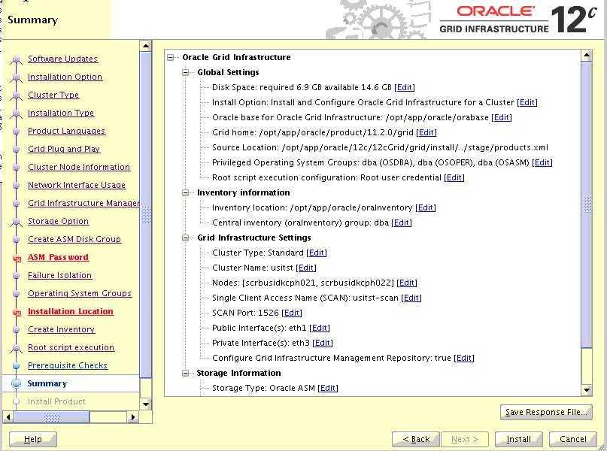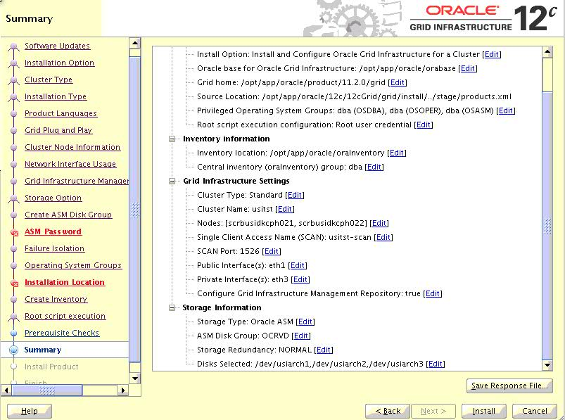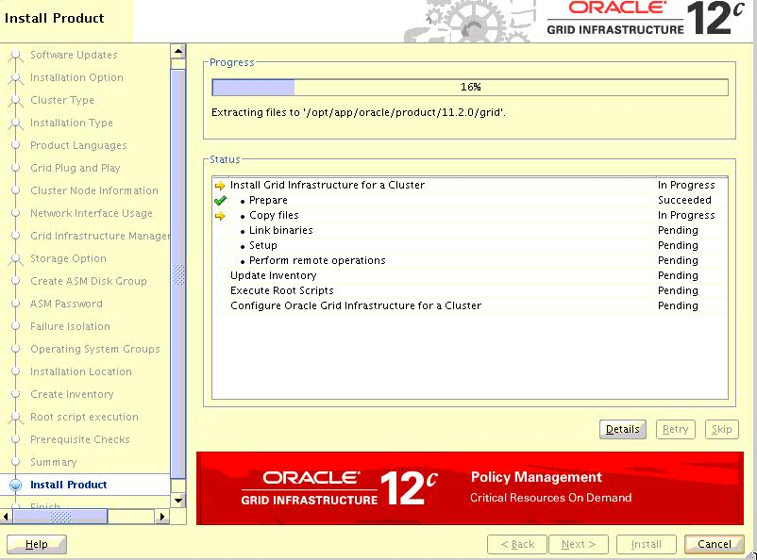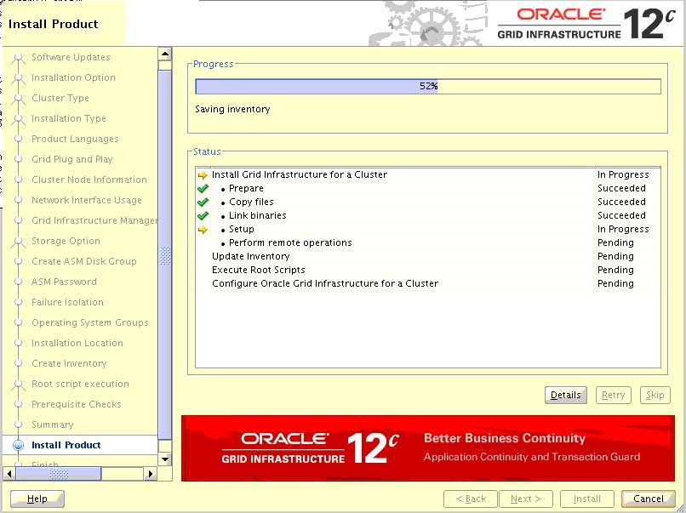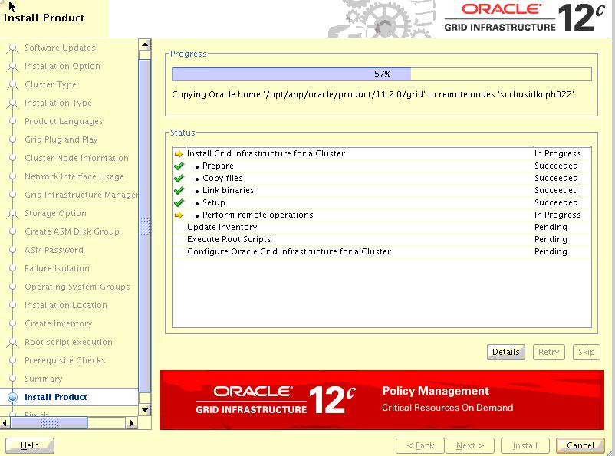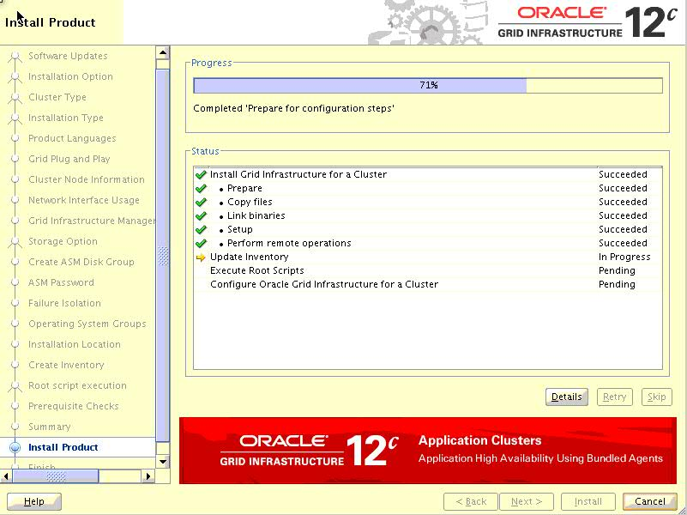

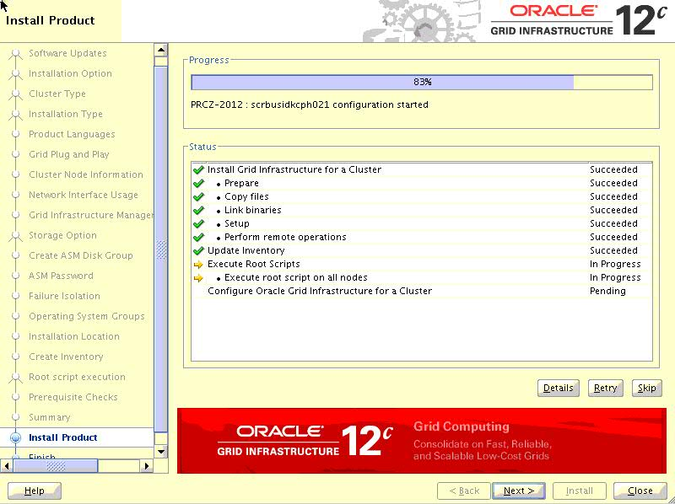

**scrbusidkcph021 :**

Performing root user operation for Oracle 12c

The following environment variables are set as:

ORACLE_OWNER= oracle

ORACLE_HOME= /opt/app/oracle/product/11.2.0/grid

Copying dbhome to /usr/local/bin ...

Copying oraenv to /usr/local/bin ...

Copying coraenv to /usr/local/bin ...

Creating /etc/oratab file...

Entries will be added to the /etc/oratab file as needed by

Database Configuration Assistant when a database is created

Finished running generic part of root script.

Now product-specific root actions will be performed.

Using configuration parameter file: /opt/app/oracle/product/11.2.0/grid/crs/install/crsconfig_params

OLR initialization - successful

root wallet

root wallet cert

root cert export

peer wallet

profile reader wallet

pa wallet

peer wallet keys

pa wallet keys

peer cert request

pa cert request

peer cert

pa cert

peer root cert TP

profile reader root cert TP

pa root cert TP

peer pa cert TP

pa peer cert TP

profile reader pa cert TP

profile reader peer cert TP

peer user cert

pa user cert

2013/07/27 05:37:50 CLSRSC-330: Adding Clusterware entries to file 'oracle-ohasd.conf'

CRS-4133: Oracle High Availability Services has been stopped.

CRS-4123: Oracle High Availability Services has been started.

CRS-4133: Oracle High Availability Services has been stopped.

CRS-4123: Oracle High Availability Services has been started.

CRS-2673: Attempting to stop 'ora.drivers.acfs' on 'scrbusidkcph021'

CRS-2677: Stop of 'ora.drivers.acfs' on 'scrbusidkcph021' succeeded

CRS-2672: Attempting to start 'ora.evmd' on 'scrbusidkcph021'

CRS-2672: Attempting to start 'ora.mdnsd' on 'scrbusidkcph021'

CRS-2676: Start of 'ora.evmd' on 'scrbusidkcph021' succeeded

CRS-2676: Start of 'ora.mdnsd' on 'scrbusidkcph021' succeeded

CRS-2672: Attempting to start 'ora.gpnpd' on 'scrbusidkcph021'

CRS-2676: Start of 'ora.gpnpd' on 'scrbusidkcph021' succeeded

CRS-2672: Attempting to start 'ora.cssdmonitor' on 'scrbusidkcph021'

CRS-2672: Attempting to start 'ora.gipcd' on 'scrbusidkcph021'

CRS-2676: Start of 'ora.cssdmonitor' on 'scrbusidkcph021' succeeded

CRS-2676: Start of 'ora.gipcd' on 'scrbusidkcph021' succeeded

CRS-2672: Attempting to start 'ora.cssd' on 'scrbusidkcph021'

CRS-2672: Attempting to start 'ora.diskmon' on 'scrbusidkcph021'

CRS-2676: Start of 'ora.diskmon' on 'scrbusidkcph021' succeeded

CRS-2676: Start of 'ora.cssd' on 'scrbusidkcph021' succeeded

ASM created and started successfully.

Disk Group OCRVD created successfully.

CRS-2672: Attempting to start 'ora.crf' on 'scrbusidkcph021'

CRS-2672: Attempting to start 'ora.storage' on 'scrbusidkcph021'

CRS-2676: Start of 'ora.storage' on 'scrbusidkcph021' succeeded

CRS-2676: Start of 'ora.crf' on 'scrbusidkcph021' succeeded

CRS-2672: Attempting to start 'ora.crsd' on 'scrbusidkcph021'

CRS-2676: Start of 'ora.crsd' on 'scrbusidkcph021' succeeded

CRS-4256: Updating the profile

Successful addition of voting disk de06a1a01c254feabffa47d7bc67c328.

Successful addition of voting disk 5cb1814d5f444f30bfcc4b20b55b7023.

Successful addition of voting disk d5e2963b5d0e4f37bff7831055c15b05.

Successfully replaced voting disk group with +OCRVD.

CRS-4256: Updating the profile

CRS-4266: Voting file(s) successfully replaced

## STATE File Universal Id File Name Disk group

-- ----- ----------------- --------- ---------

1. ONLINE de06a1a01c254feabffa47d7bc67c328 (/dev/usiarch1) [OCRVD]

2. ONLINE 5cb1814d5f444f30bfcc4b20b55b7023 (/dev/usiarch2) [OCRVD]

3. ONLINE d5e2963b5d0e4f37bff7831055c15b05 (/dev/usiarch3) [OCRVD]

Located 3 voting disk(s).

CRS-2791: Starting shutdown of Oracle High Availability Services-managed resources on 'scrbusidkcph021'

CRS-2673: Attempting to stop 'ora.crsd' on 'scrbusidkcph021'

CRS-2677: Stop of 'ora.crsd' on 'scrbusidkcph021' succeeded

CRS-2673: Attempting to stop 'ora.drivers.acfs' on 'scrbusidkcph021'

CRS-2673: Attempting to stop 'ora.ctssd' on 'scrbusidkcph021'

CRS-2673: Attempting to stop 'ora.evmd' on 'scrbusidkcph021'

CRS-2673: Attempting to stop 'ora.storage' on 'scrbusidkcph021'

CRS-2673: Attempting to stop 'ora.crf' on 'scrbusidkcph021'

CRS-2673: Attempting to stop 'ora.mdnsd' on 'scrbusidkcph021'

CRS-2673: Attempting to stop 'ora.gpnpd' on 'scrbusidkcph021'

CRS-2677: Stop of 'ora.drivers.acfs' on 'scrbusidkcph021' succeeded

CRS-2677: Stop of 'ora.storage' on 'scrbusidkcph021' succeeded

CRS-2673: Attempting to stop 'ora.asm' on 'scrbusidkcph021'

CRS-2677: Stop of 'ora.mdnsd' on 'scrbusidkcph021' succeeded

CRS-2677: Stop of 'ora.crf' on 'scrbusidkcph021' succeeded

CRS-2677: Stop of 'ora.gpnpd' on 'scrbusidkcph021' succeeded

CRS-2677: Stop of 'ora.evmd' on 'scrbusidkcph021' succeeded

CRS-2677: Stop of 'ora.ctssd' on 'scrbusidkcph021' succeeded

CRS-2677: Stop of 'ora.asm' on 'scrbusidkcph021' succeeded

CRS-2673: Attempting to stop 'ora.cluster_interconnect.haip' on 'scrbusidkcph021'

CRS-2677: Stop of 'ora.cluster_interconnect.haip' on 'scrbusidkcph021' succeeded

CRS-2673: Attempting to stop 'ora.cssd' on 'scrbusidkcph021'

CRS-2677: Stop of 'ora.cssd' on 'scrbusidkcph021' succeeded

CRS-2673: Attempting to stop 'ora.gipcd' on 'scrbusidkcph021'

CRS-2677: Stop of 'ora.gipcd' on 'scrbusidkcph021' succeeded

CRS-2793: Shutdown of Oracle High Availability Services-managed resources on 'scrbusidkcph021' has completed

CRS-4133: Oracle High Availability Services has been stopped.

CRS-4123: Starting Oracle High Availability Services-managed resources

CRS-2672: Attempting to start 'ora.mdnsd' on 'scrbusidkcph021'

CRS-2672: Attempting to start 'ora.evmd' on 'scrbusidkcph021'

CRS-2676: Start of 'ora.evmd' on 'scrbusidkcph021' succeeded

CRS-2676: Start of 'ora.mdnsd' on 'scrbusidkcph021' succeeded

CRS-2672: Attempting to start 'ora.gpnpd' on 'scrbusidkcph021'

CRS-2676: Start of 'ora.gpnpd' on 'scrbusidkcph021' succeeded

CRS-2672: Attempting to start 'ora.gipcd' on 'scrbusidkcph021'

CRS-2676: Start of 'ora.gipcd' on 'scrbusidkcph021' succeeded

CRS-2672: Attempting to start 'ora.cssdmonitor' on 'scrbusidkcph021'

CRS-2676: Start of 'ora.cssdmonitor' on 'scrbusidkcph021' succeeded

CRS-2672: Attempting to start 'ora.cssd' on 'scrbusidkcph021'

CRS-2672: Attempting to start 'ora.diskmon' on 'scrbusidkcph021'

CRS-2676: Start of 'ora.diskmon' on 'scrbusidkcph021' succeeded

CRS-2789: Cannot stop resource 'ora.diskmon' as it is not running on server 'scrbusidkcph021'

CRS-2676: Start of 'ora.cssd' on 'scrbusidkcph021' succeeded

CRS-2672: Attempting to start 'ora.cluster_interconnect.haip' on 'scrbusidkcph021'

CRS-2672: Attempting to start 'ora.ctssd' on 'scrbusidkcph021'

CRS-2676: Start of 'ora.ctssd' on 'scrbusidkcph021' succeeded

CRS-2676: Start of 'ora.cluster_interconnect.haip' on 'scrbusidkcph021' succeeded

CRS-2672: Attempting to start 'ora.asm' on 'scrbusidkcph021'

CRS-2676: Start of 'ora.asm' on 'scrbusidkcph021' succeeded

CRS-2672: Attempting to start 'ora.storage' on 'scrbusidkcph021'

CRS-2676: Start of 'ora.storage' on 'scrbusidkcph021' succeeded

CRS-2672: Attempting to start 'ora.crf' on 'scrbusidkcph021'

CRS-2676: Start of 'ora.crf' on 'scrbusidkcph021' succeeded

CRS-2672: Attempting to start 'ora.crsd' on 'scrbusidkcph021'

CRS-2676: Start of 'ora.crsd' on 'scrbusidkcph021' succeeded

CRS-6023: Starting Oracle Cluster Ready Services-managed resources

CRS-6017: Processing resource auto-start for servers: scrbusidkcph021

CRS-6016: Resource auto-start has completed for server scrbusidkcph021

CRS-6024: Completed start of Oracle Cluster Ready Services-managed resources

CRS-4123: Oracle High Availability Services has been started.

2013/07/27 05:47:03 CLSRSC-343: Successfully started Oracle clusterware stack

CRS-2672: Attempting to start 'ora.asm' on 'scrbusidkcph021'

CRS-2676: Start of 'ora.asm' on 'scrbusidkcph021' succeeded

CRS-2672: Attempting to start 'ora.OCRVD.dg' on 'scrbusidkcph021'

CRS-2676: Start of 'ora.OCRVD.dg' on 'scrbusidkcph021' succeeded

Preparing packages for installation...

cvuqdisk-1.0.9-1

2013/07/27 05:48:27 CLSRSC-325: Configure Oracle Grid Infrastructure for a Cluster ... succeeded

**scrbusidkcph022**

Performing root user operation for Oracle 12c

The following environment variables are set as:

ORACLE_OWNER= oracle

ORACLE_HOME= /opt/app/oracle/product/11.2.0/grid

Copying dbhome to /usr/local/bin ...

Copying oraenv to /usr/local/bin ...

Copying coraenv to /usr/local/bin ...

Creating /etc/oratab file...

Entries will be added to the /etc/oratab file as needed by

Database Configuration Assistant when a database is created

Finished running generic part of root script.

Now product-specific root actions will be performed.

Using configuration parameter file: /opt/app/oracle/product/11.2.0/grid/crs/install/crsconfig_params

OLR initialization - successful

2013/07/27 05:48:53 CLSRSC-330: Adding Clusterware entries to file 'oracle-ohasd.conf'

CRS-4133: Oracle High Availability Services has been stopped.

CRS-4123: Oracle High Availability Services has been started.

CRS-4133: Oracle High Availability Services has been stopped.

CRS-4123: Oracle High Availability Services has been started.

CRS-2791: Starting shutdown of Oracle High Availability Services-managed resources on 'scrbusidkcph022'

CRS-2673: Attempting to stop 'ora.drivers.acfs' on 'scrbusidkcph022'

CRS-2677: Stop of 'ora.drivers.acfs' on 'scrbusidkcph022' succeeded

CRS-2793: Shutdown of Oracle High Availability Services-managed resources on 'scrbusidkcph022' has completed

CRS-4133: Oracle High Availability Services has been stopped.

CRS-4123: Starting Oracle High Availability Services-managed resources

CRS-2672: Attempting to start 'ora.mdnsd' on 'scrbusidkcph022'

CRS-2672: Attempting to start 'ora.evmd' on 'scrbusidkcph022'

CRS-2676: Start of 'ora.evmd' on 'scrbusidkcph022' succeeded

CRS-2676: Start of 'ora.mdnsd' on 'scrbusidkcph022' succeeded

CRS-2672: Attempting to start 'ora.gpnpd' on 'scrbusidkcph022'

CRS-2676: Start of 'ora.gpnpd' on 'scrbusidkcph022' succeeded

CRS-2672: Attempting to start 'ora.gipcd' on 'scrbusidkcph022'

CRS-2676: Start of 'ora.gipcd' on 'scrbusidkcph022' succeeded

CRS-2672: Attempting to start 'ora.cssdmonitor' on 'scrbusidkcph022'

CRS-2676: Start of 'ora.cssdmonitor' on 'scrbusidkcph022' succeeded

CRS-2672: Attempting to start 'ora.cssd' on 'scrbusidkcph022'

CRS-2672: Attempting to start 'ora.diskmon' on 'scrbusidkcph022'

CRS-2676: Start of 'ora.diskmon' on 'scrbusidkcph022' succeeded

CRS-2789: Cannot stop resource 'ora.diskmon' as it is not running on server 'scrbusidkcph022'

CRS-2676: Start of 'ora.cssd' on 'scrbusidkcph022' succeeded

CRS-2672: Attempting to start 'ora.cluster_interconnect.haip' on 'scrbusidkcph022'

CRS-2672: Attempting to start 'ora.ctssd' on 'scrbusidkcph022'

CRS-2676: Start of 'ora.ctssd' on 'scrbusidkcph022' succeeded

CRS-2676: Start of 'ora.cluster_interconnect.haip' on 'scrbusidkcph022' succeeded

CRS-2672: Attempting to start 'ora.asm' on 'scrbusidkcph022'

CRS-2676: Start of 'ora.asm' on 'scrbusidkcph022' succeeded

CRS-2672: Attempting to start 'ora.storage' on 'scrbusidkcph022'

CRS-2676: Start of 'ora.storage' on 'scrbusidkcph022' succeeded

CRS-2672: Attempting to start 'ora.crf' on 'scrbusidkcph022'

CRS-2676: Start of 'ora.crf' on 'scrbusidkcph022' succeeded

CRS-2672: Attempting to start 'ora.crsd' on 'scrbusidkcph022'

CRS-2676: Start of 'ora.crsd' on 'scrbusidkcph022' succeeded

CRS-6017: Processing resource auto-start for servers: scrbusidkcph022

CRS-2673: Attempting to stop 'ora.LISTENER_SCAN1.lsnr' on 'scrbusidkcph021'

CRS-2672: Attempting to start 'ora.ons' on 'scrbusidkcph022'

CRS-2677: Stop of 'ora.LISTENER_SCAN1.lsnr' on 'scrbusidkcph021' succeeded

CRS-2673: Attempting to stop 'ora.scan1.vip' on 'scrbusidkcph021'

CRS-2677: Stop of 'ora.scan1.vip' on 'scrbusidkcph021' succeeded

CRS-2672: Attempting to start 'ora.scan1.vip' on 'scrbusidkcph022'

CRS-2676: Start of 'ora.scan1.vip' on 'scrbusidkcph022' succeeded

CRS-2672: Attempting to start 'ora.LISTENER_SCAN1.lsnr' on 'scrbusidkcph022'

CRS-2676: Start of 'ora.ons' on 'scrbusidkcph022' succeeded

CRS-2676: Start of 'ora.LISTENER_SCAN1.lsnr' on 'scrbusidkcph022' succeeded

CRS-6016: Resource auto-start has completed for server scrbusidkcph022

CRS-6024: Completed start of Oracle Cluster Ready Services-managed resources

CRS-4123: Oracle High Availability Services has been started.

2013/07/27 05:56:20 CLSRSC-343: Successfully started Oracle clusterware stack

Preparing packages for installation...

cvuqdisk-1.0.9-1

2013/07/27 05:56:38 CLSRSC-325: Configure Oracle Grid Infrastructure for a Cluster ... succeeded

